USEFUL BASH SCRIPTING STUFF

regarding the DECLARE statement:
from > http://tldp.org/LDP/abs/html/declareref.html <

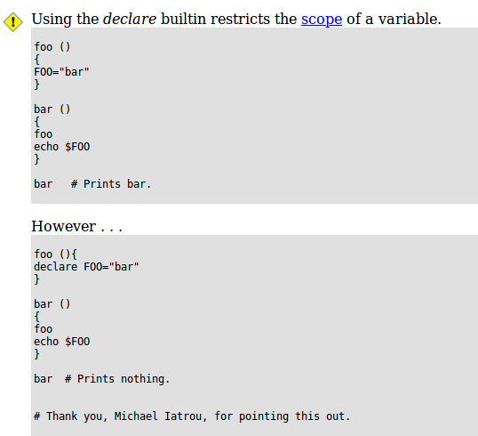

regarding variable assignment and quoting
→ read http://tldp.org/HOWTO/Bash-Prog-Intro-HOWTO-5.html#ss5.1
and the following chapters

